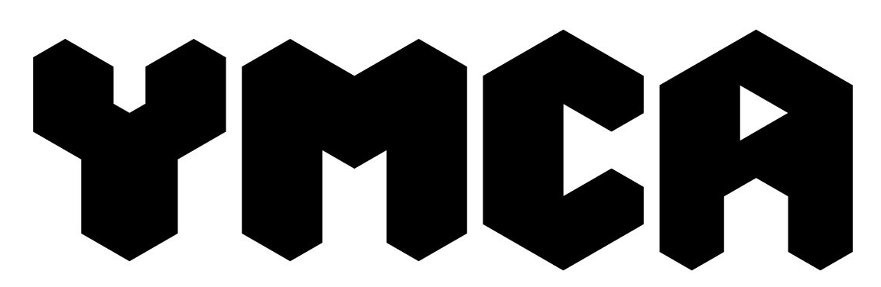
MINIBUS BOOKING FORM (2025)
Please type or print clearly

Name of group / organisation if applicable
Contact name:
Job title:
(if group/organisation hiring)
Contact/Invoice address:
Postcode: |  | Telephone no:
Email:

Details of booking: | Day | Date | Time
Start of booking:
End of booking:
Purpose of booking/ Where travelling to:
Name(s) of driver:
(Must have D1 on license)

Declaration:
I agree to collect the key and vehicle at the time the booking starts and return them at the end of the booking period as agreed with the Chief Operations Officer. The hire charge to be paid will be agreed in advance and invoiced after use to be paid by BACS bank transfer.

I agree that we will pay for fuel used during the booking and return it with the same amount of diesel in the tank as when our booking started or if this does not happen we will be invoiced for the fuel based on mileage travelled.
(Please clean the vehicle at the end of use and leave rubbish free and the floor brushed).

I agree to indemnify YMCA Bournemouth against any accident or injury resulting from use of the vehicle and agree to pay for any item damaged or broken above ‘fair wear and tear’ during the hiring. An excess may have to be paid for damage caused to the vehicle if an insurance claim has to be made.

I agree that we will pay any fines/parking tickets incurred by our drivers during our use of the vehicle.

I agree that we will not allow anyone to drive the vehicle who has not been authorised to do so by YMCA Bournemouth, and their details will be checked prior to use.

If you have to cancel your booking please give as much notice as possible.
You may be charged for the hire still if less than 48 hours are given.
Signed: |  | Date:
Name (Block capitals):

Please return this form to: mark.inkpen@ymcabournemouth.org.uk

